A Course Work Project Report

*On*

“**Amazon Clone**”

*By*

KARAN SAJEETH (0120190150)

HIMANSHU SENGAR (0120190148)

ABHISEK NAYAK (0120190159)

SHANTANU KADAM (0120190155)

*Of*

**CS346L: Web Technology**

**T.Y. BTech**

**Academic Year: 2021-2022**

**School of Computer Engineering & Technology**



**Contents**

|  |  |  |  |
| --- | --- | --- | --- |
| **Sr. No.** | **Topic** | | **Page No.** |
| **Chapter-1** | **Introduction** | | 3 |
|  | 1.1 | Objective | 3 |
|  | 1.2 | Introduction to Project | 3 |
|  | 1.3 | Elements of e-commerce | 4 |
| **Chapter-2** | **Database Design** | | 6 |
|  | 2.1 | Introduction | 6 |
|  | 2.2 | Design interface | 6 |
|  | 2.3 | Database design | 7 |
| **Chapter-3** | **API/Library** | | 9 |
|  | 3.1 | Introduction | 9 |
|  | 3.2 | Usage in project | 10 |
| **Chapter-4** | **Results (Screen shots)** | | 11 |
| **Chapter-5** | **Conclusion** | | 14 |
|  | **References** | | 14 |

**Chapter 1**

**Introduction**

* 1. **Objective**
  + Create user-friendly interface of website

### Validate user information through database

### Usage of MEAN stack in application

* 1. **Introduction of project**
* Our project implements the simple working of an ecommerce website like Amazon.
* The home page will have a navbar for searching products, categories, login and signup component and products.
* User can login or register himself in the respective pages and his data will be stored in the database.
* Once customer entered with his own username and password, at that time automatically he will be logged in and once user selects an item, it will be added to cart. In case user thinks the selected item is not useful, then he can delete that item from the cart.
* The cart will display the added products, its quantity and total price to be paid by the user.

**1.3 Elements of e-commerce**

1) **A Product or service**: In case of E-Commerce, it is virtual product shown on a web site. One can demonstrate multimedia presentation of the product & its entire feature on the web page itself, which may not be possible in case of physical products of commerce activity.

2) **A Place to sell the products:** In the E-Commerce case, a website displays the products in all ways & act as a place for E-Commerce.

3) **A way to get customers to visit your website:** In case of E-Commerce search engines and linkages with other web sites play an important role in helping the customers to reach web sites of the E-organizations.

4) **A way to accept money:** In case of traditional commerce, buyers and sellers are in direct contact with each other. The payments in E-Commerce are made using Electronic fund Transfer in various form using credit cards, smart cards, c-checks etc. the information of payment is routed through Value added Networks (VANS) and Payment Gateway Systems etc.

* 1. **Client Server Architecture**

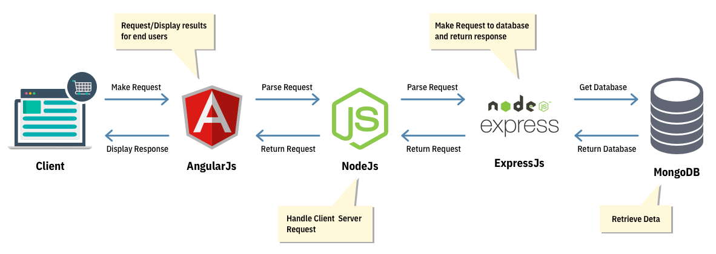

The User will open the application and will be directed to the home page. There will be an option to either login or signup. The user data entered here will be stored in the database. User can add or search for products and purchase them from the cart accordingly.

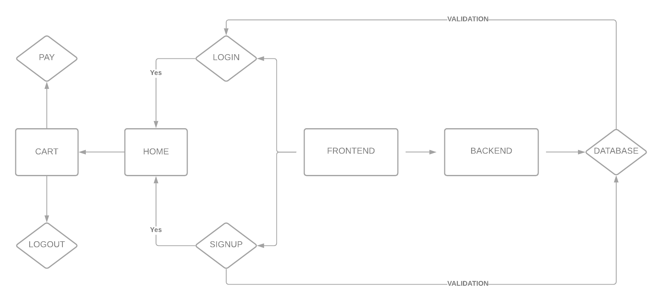

**Chapter 2**

**DATABASE DESIGN**

**2.1 DESIGN SPECIFICATION**

2.1.1 CUSTOMER INTERFACE

The interface of the website is simple to understand as the navbar will contain all the components that the user can interact with. Login and register buttons are provided to access one’s account and cart will contain the products that are added into the shopping list.

2.1.2 HOME PAGE

A home page is a webpage that serves as the starting point of website. It is the default webpage that loads when visit a web. The home page is located in the root directory of a website. It contains the login and register buttons in the navbar along with cart interface. There are categories provided for each type with various products included in it which can also be searched using the search bar.

2.1.4 ADD PRODUCT

We can add our desired product to the cart simply by add to cart button and checkout in the cart section.

**2.3 DATABASE DESIGN**

The first thing in building any E-commerce app is creating the underlying database to support it. For this we have used Mongo dB

2.3.1 Basic Design Principles

* We have created a database in Mongo dB Atlas and connected it to the frontend via NodeJS and express.
* For this we have a config.js file that checks for valid connection of the database if the key is correct.
* The server.js runs only if the configuration of the database will be valid.
* The database will store the name, email and password of the user via backend.
* Data service, Rest API service and Auth guard service will be the services used to validate the login and signup process of the users and store their data in the database.
* JsonWebtoken is used to generate token that will be provided to the user for the time that he is logged in the website and will expire when logged out.
* To maintain data privacy, Bcrypt is used to encrypt passwords of users while storing it in the database.

2.3.2MONGODB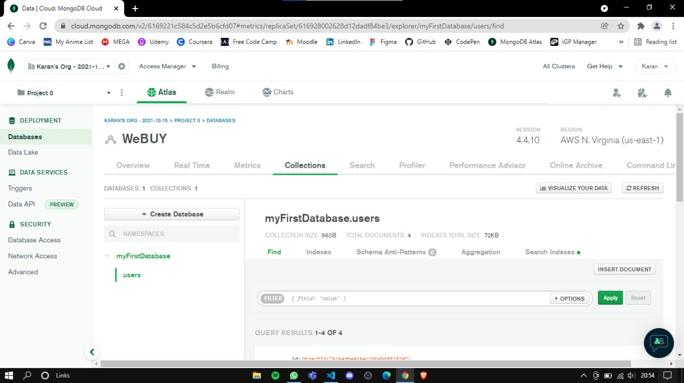

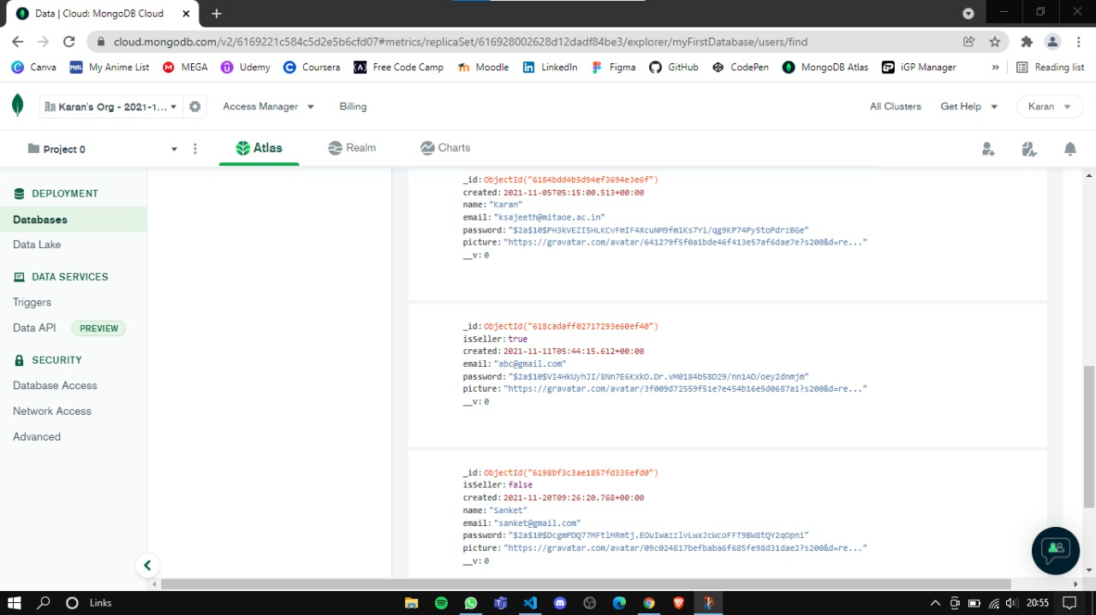

**Chapter 3**

**API/LIBRARY**

3.1 Introduction

**Dependencies used in the project:** - Bootstrap, Cors, Mongoose, Express, Body-parser, Morgan, Nodemon, Bcrypt.

**Modules used:** - NgModule, FormsModule, Reactive forms module, Httpclientmodule and Browser module.

**Services used:** - cart service, RestAPI service, data service, auth-guard service and API service.

**APIs used in the project:** - JsonWebtoken, fakeproductsapi, login and signup.

3.2 Usage in project

* Bootstrap- It is used to add responsive design directly into html code.
* Mongoose- It manages relationships between data, provides schema validation, and is used to translate between objects in code and the representation of those objects in MongoDB.
* Cors- It allows us to relax the security applied to an API.
* Morgan- It simplifies the process of logging requests to your application.
* Express- It helps you manage everything, from routes, to handling requests and views.
* Bcrypt- It encrypts and allows you to easily create a hash out of a password string.
* NgModule- It declares which components, directives, and pipes belong to the module.
* Forms module- It allows you to isolate and work with a specific form on a HTML page.
* Browser module- It provides services that are essential to launch and run a browser application.
* Httpclientmodule- It is a service module provided by Angular that allows us to perform HTTP requests and easily manipulate those requests and their responses.
* Cart service- For getting product details in cart
* RestAPI service- It uses HTTP requests to access and use data. That data can be used to GET, PUT, POST and DELETE data types.
* Data service- They focus on presenting data and delegate data access to a service.
* Auth-guard service- It decides whether the user has access/permission to view specific page / route / path in the application or not.
* JsonWebtoken- You can use jwt.io to decode, verify, and produce JWT. JWT specifies a compact and self-contained method for communicating information as a JSON object between two parties.
* Fakeproductsapi – List of auto generated products and their data.
* Login and signup- Used to validate credential data and manages user session in the application.

**Chapter 4**

**RESULTS (Screen shots)**

**Customer login page**

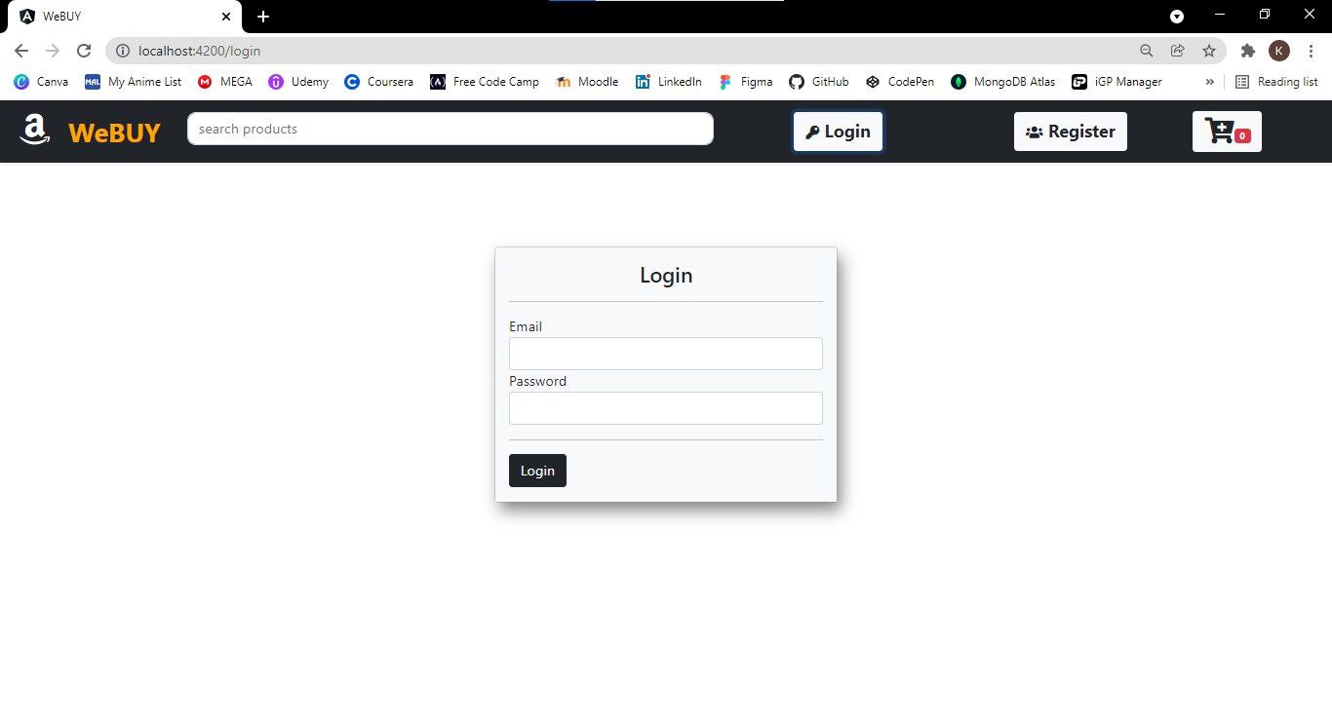

**Customer registration page**

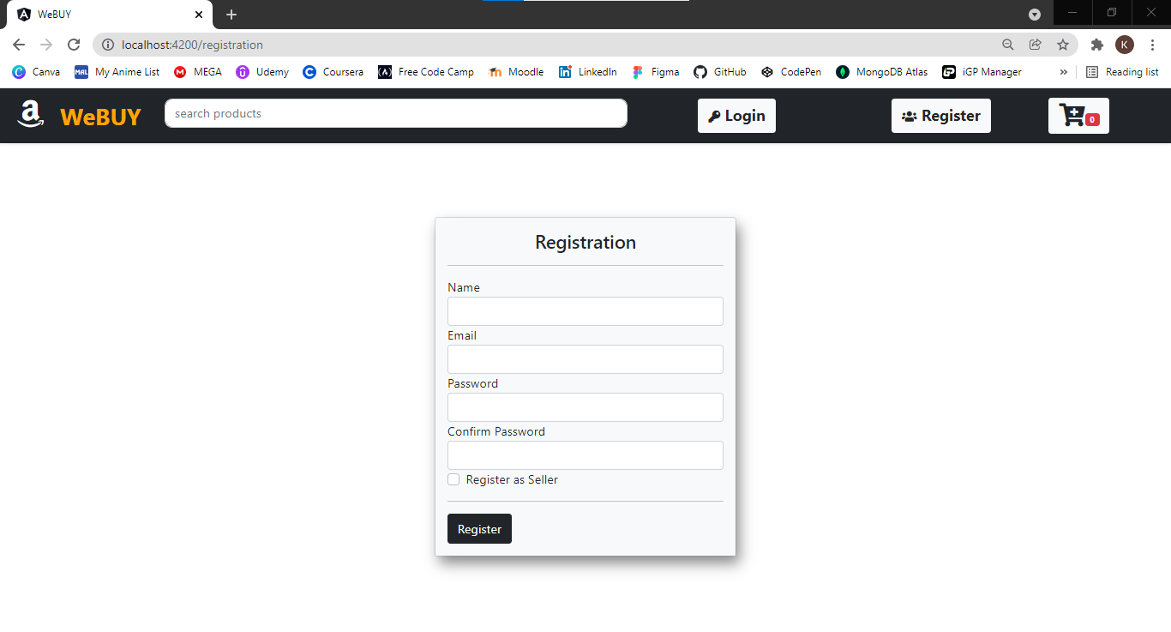

**Home page**

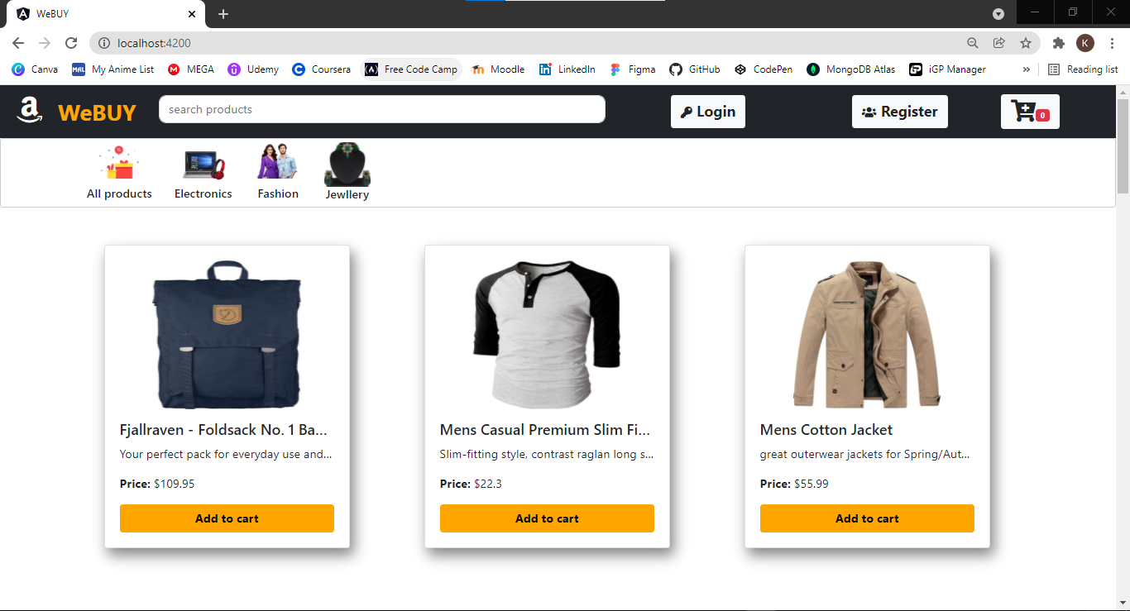

**Product or search page**

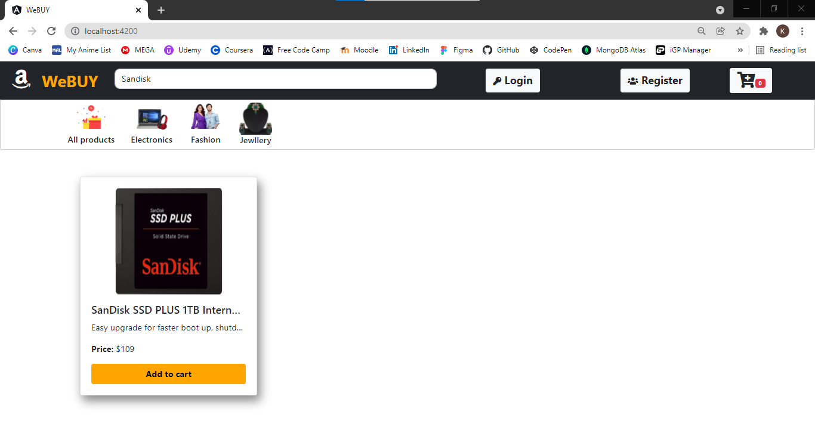

**Cart page before checkout**

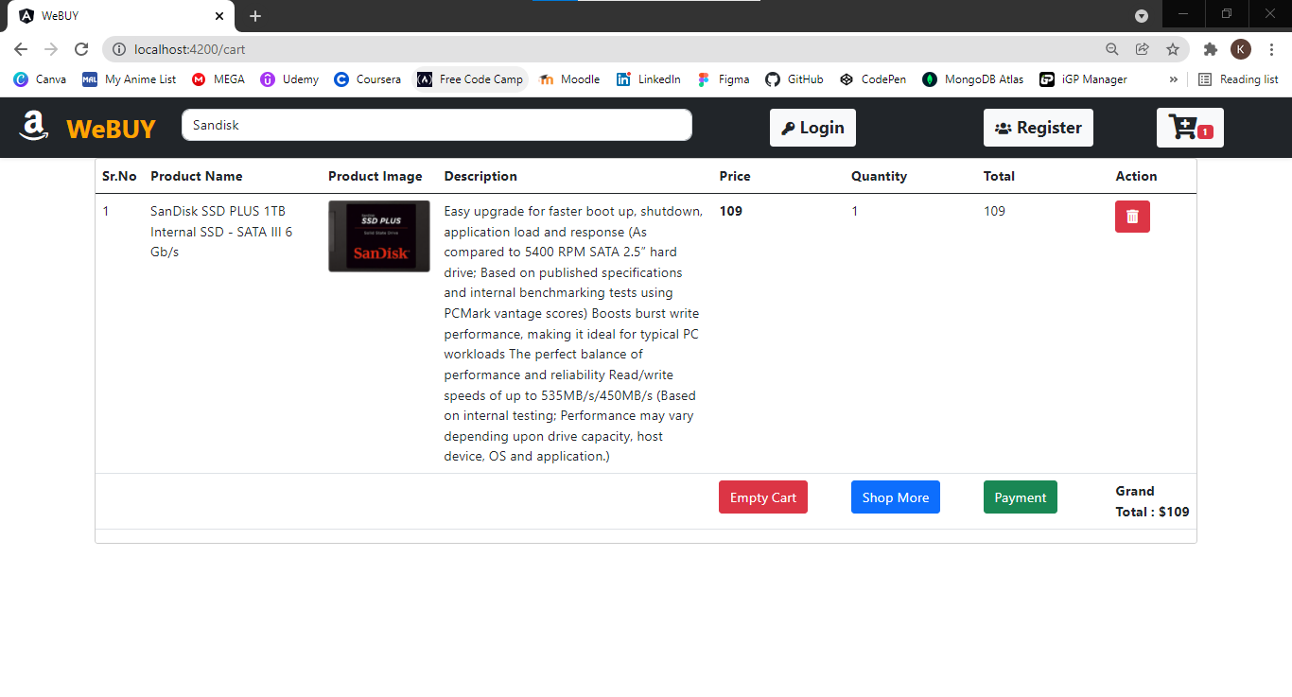

**Transaction page**

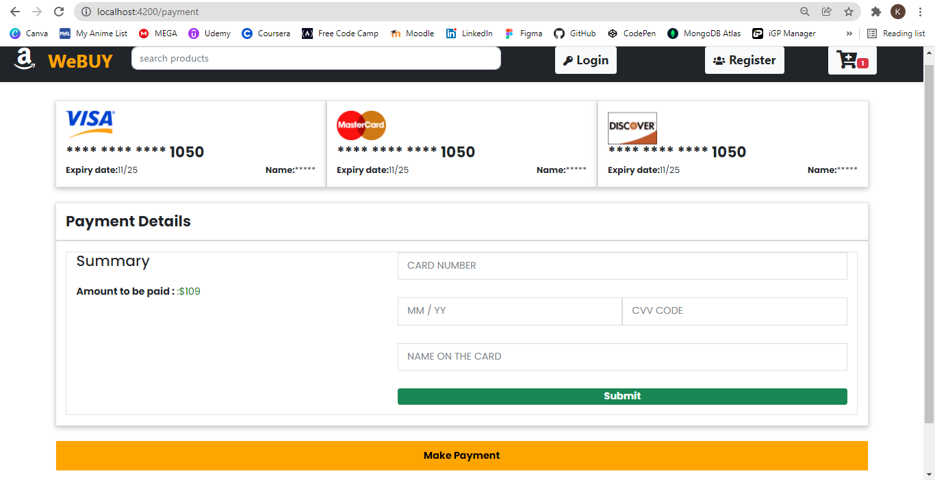

**Chapter 5**

**CONCLUSION**

Overall in the project, we have understood the MEAN stack workflow and implementation. Building a website like Amazon requires a lot of data and coding skills but a simple website as ours can be done with the understanding of angular, node and mongo db. Thus we would like to conclude by saying that we have understood the mean stack process for creating an ecommerce website and successfully implemented the project.

**References**

1. <https://www.udemy.com/share/101Jxa3@1oQQLb4qL2UszUy9HrkndbPGZVWsWiDfR7P9vOtOxbhCNPW4LHc5ceBFP9mxsxwd4Q==/>
2. <https://www.positronx.io/mean-stack-tutorial-angular-7-crud-bootstrap/>
3. <https://youtu.be/0D5EEKH97NA>
4. <https://youtu.be/uvW3C2fmFGY>
5. <https://steemit.com/utopian-io/@gotgame/tutorial-1-building-an-ecommerce-application-with-the-mean-stack>
6. <https://fakestoreapi.com/products/>